







Software Requirements Specification

ReadySetResource.com

Contents

4.1 - Purpose 3

4.2 - Critical Requirements 3

4.3 - Functional and Non-Functional Requirements 3

Non-Functional Requirements 4

4.4 - User Requirements 4

4.5 - Assumptions 5

4.6 - Constraints 5

Monetary Constrains 5

Time Constrains 5

Resource Constrains 5

4.7 - Dependancies 5

4.8 - High Level System Logic 6

www. 6

get. 7

legal. 7

contact. 7

help. 8

admin. 8

dev. 9

sa. 9

head. 9

im. 10

4.9 - Bibliography 11

4.10 - Software Requirements Spec. Work Log 11

# 4.1 - Purpose

The purpose of this project is to be able to aid in the productivity of backend logistics within the public sector. Maximizing effectiveness and efficiency is key in aiding productivity and being able to provide all details necessary for employees to be able to work easier with less distractions would benefit members of staff and thus will strive for these targets in this project.

# 4.2 - Critical Requirements

The system that will be built must be able to:

* + - Display the website to provide information on the web apps
    - Allow the user of the system to contact a member of staff in a contact form
    - Sign a company or a business up to the service
    - Charge a customer on a monthly/yearly basis
    - Allow the ‘administrator’ of a company to:
      * + Add, delete and modify users’ details
        + Create rotas
        + Message members of staff
    - Allow employees of a company to:
      * + View their rotas
        + Message other members of staff
    - Allow experts to:
      * + Add, delete and modify users’ details
        + Add, delete and modify companies’ details
        + Query a database of questions
        + Respond to questions
        + Close questions
    - Allow developers to:
      * + Shut down and start up the system

# 4.3 - Functional and Non-Functional Requirements

Functional requirements, put simply, are what the system that is being built must do. Non-functional requirements are interested in defining other constraints and achievements. To see a list of the functional requirements please go to 2.13 - General System Requirements in the 2 - Planning Report.

Non-Functional Requirements

Performance: The website needs to run smoothly and reliably. To achieve this we need to look at the capacity of the server and to not DOS it by accident by controlling RAM usage per user and number of users.

Capacity: Through multiple tests that have been conducted, the average usage of RAM per user is around 80MB. Assuming that it is both the same for the client as the server (although it probably will differ) the hosting plan that will be purchased will be 2GB of RAM and therefore at any one time the system can have 25 users. More tests will need to be done so that we can ensure that those figures are correct, but once the project starts to grow we are able to upgrade the hosting plan and even move it to our own servers.

Availability: The website will be available world-wide but you may only register if you are a company in the UK. This is due to legalities and due to the server being hosted in the UK which means speeds will be reduced to other countries.

Fault Tolerance: Maintaining high cohesion and low coupling will ensure that fault tolerance is minimum. After release, more tests will be carried out to ensure that fault tolerance is dealt with as much as possible.

Quality of Service: The quality that is produced needs to be as high as possible as this will entice users to use the system more and recommend to others.

Portability: We are going to ensure that the website can be viewed dynamically on computers, laptops, tablets and phones. Due to the increase usage of mobile devices, a large portion of users would be excluded if the website was not portable.

# 4.4 - User Requirements

In this system, all the general requirements are also user requirements. To see a list of the functional requirements please go to 2.13 - General System Requirements in the 2 - Planning Report.

# 4.5 - Assumptions

There are many assumptions to make about this project. The main ones being:

* + - I can meet the deadline and complete every aspect of the project
    - That people can navigate and use the computer and internet with ease
    - That people can speak English (and in the future Spanish)
    - That the website will be able to be hosted and published to a hosting environment
    - The file hosting platform will be safe, secure and reliable
    - The developer(s) can write the software required of them

# 4.6 - Constraints

Monetary Constrains

Due to the nature of this project, the monetary constraints for this project will be outlined in the Business Plan. This will provide an in-depth look at estimated costs, profits, break even analysis and more.

Time Constrains

City of Glasgow College has put upon the project many deadlines for different aspects of the project. To view a full list of deadlines please view 3 - Student’s Agreement.

Resource Constrains

Due to the monetary constrains, we are not able to purchase hardware and therefore must use hosting environments which will reduce the short-term costs but increase the long-term cost and will also limit the main memory and processing power. In addition, there are currently a shortage of workers dedicated to this project and will require an increase of man power if we wish the project to stay afloat.

# 4.7 - Dependencies

The main dependencies of the project are:

* + - Acceptance from the lecturers required to be able to develop this project
    - The Integrated Development Environment will allow us to publish the project for free
    - The web host will be cheap, easy to use and consistently reliable
    - A good knowledge of the Software Development Life Cycle from all parties

# 4.8 - High Level System Logic

There will be a total of 10 websites that co-exist in the same domain name all under different subdomains. The overall collection of websites are diagrammed as followed to show the 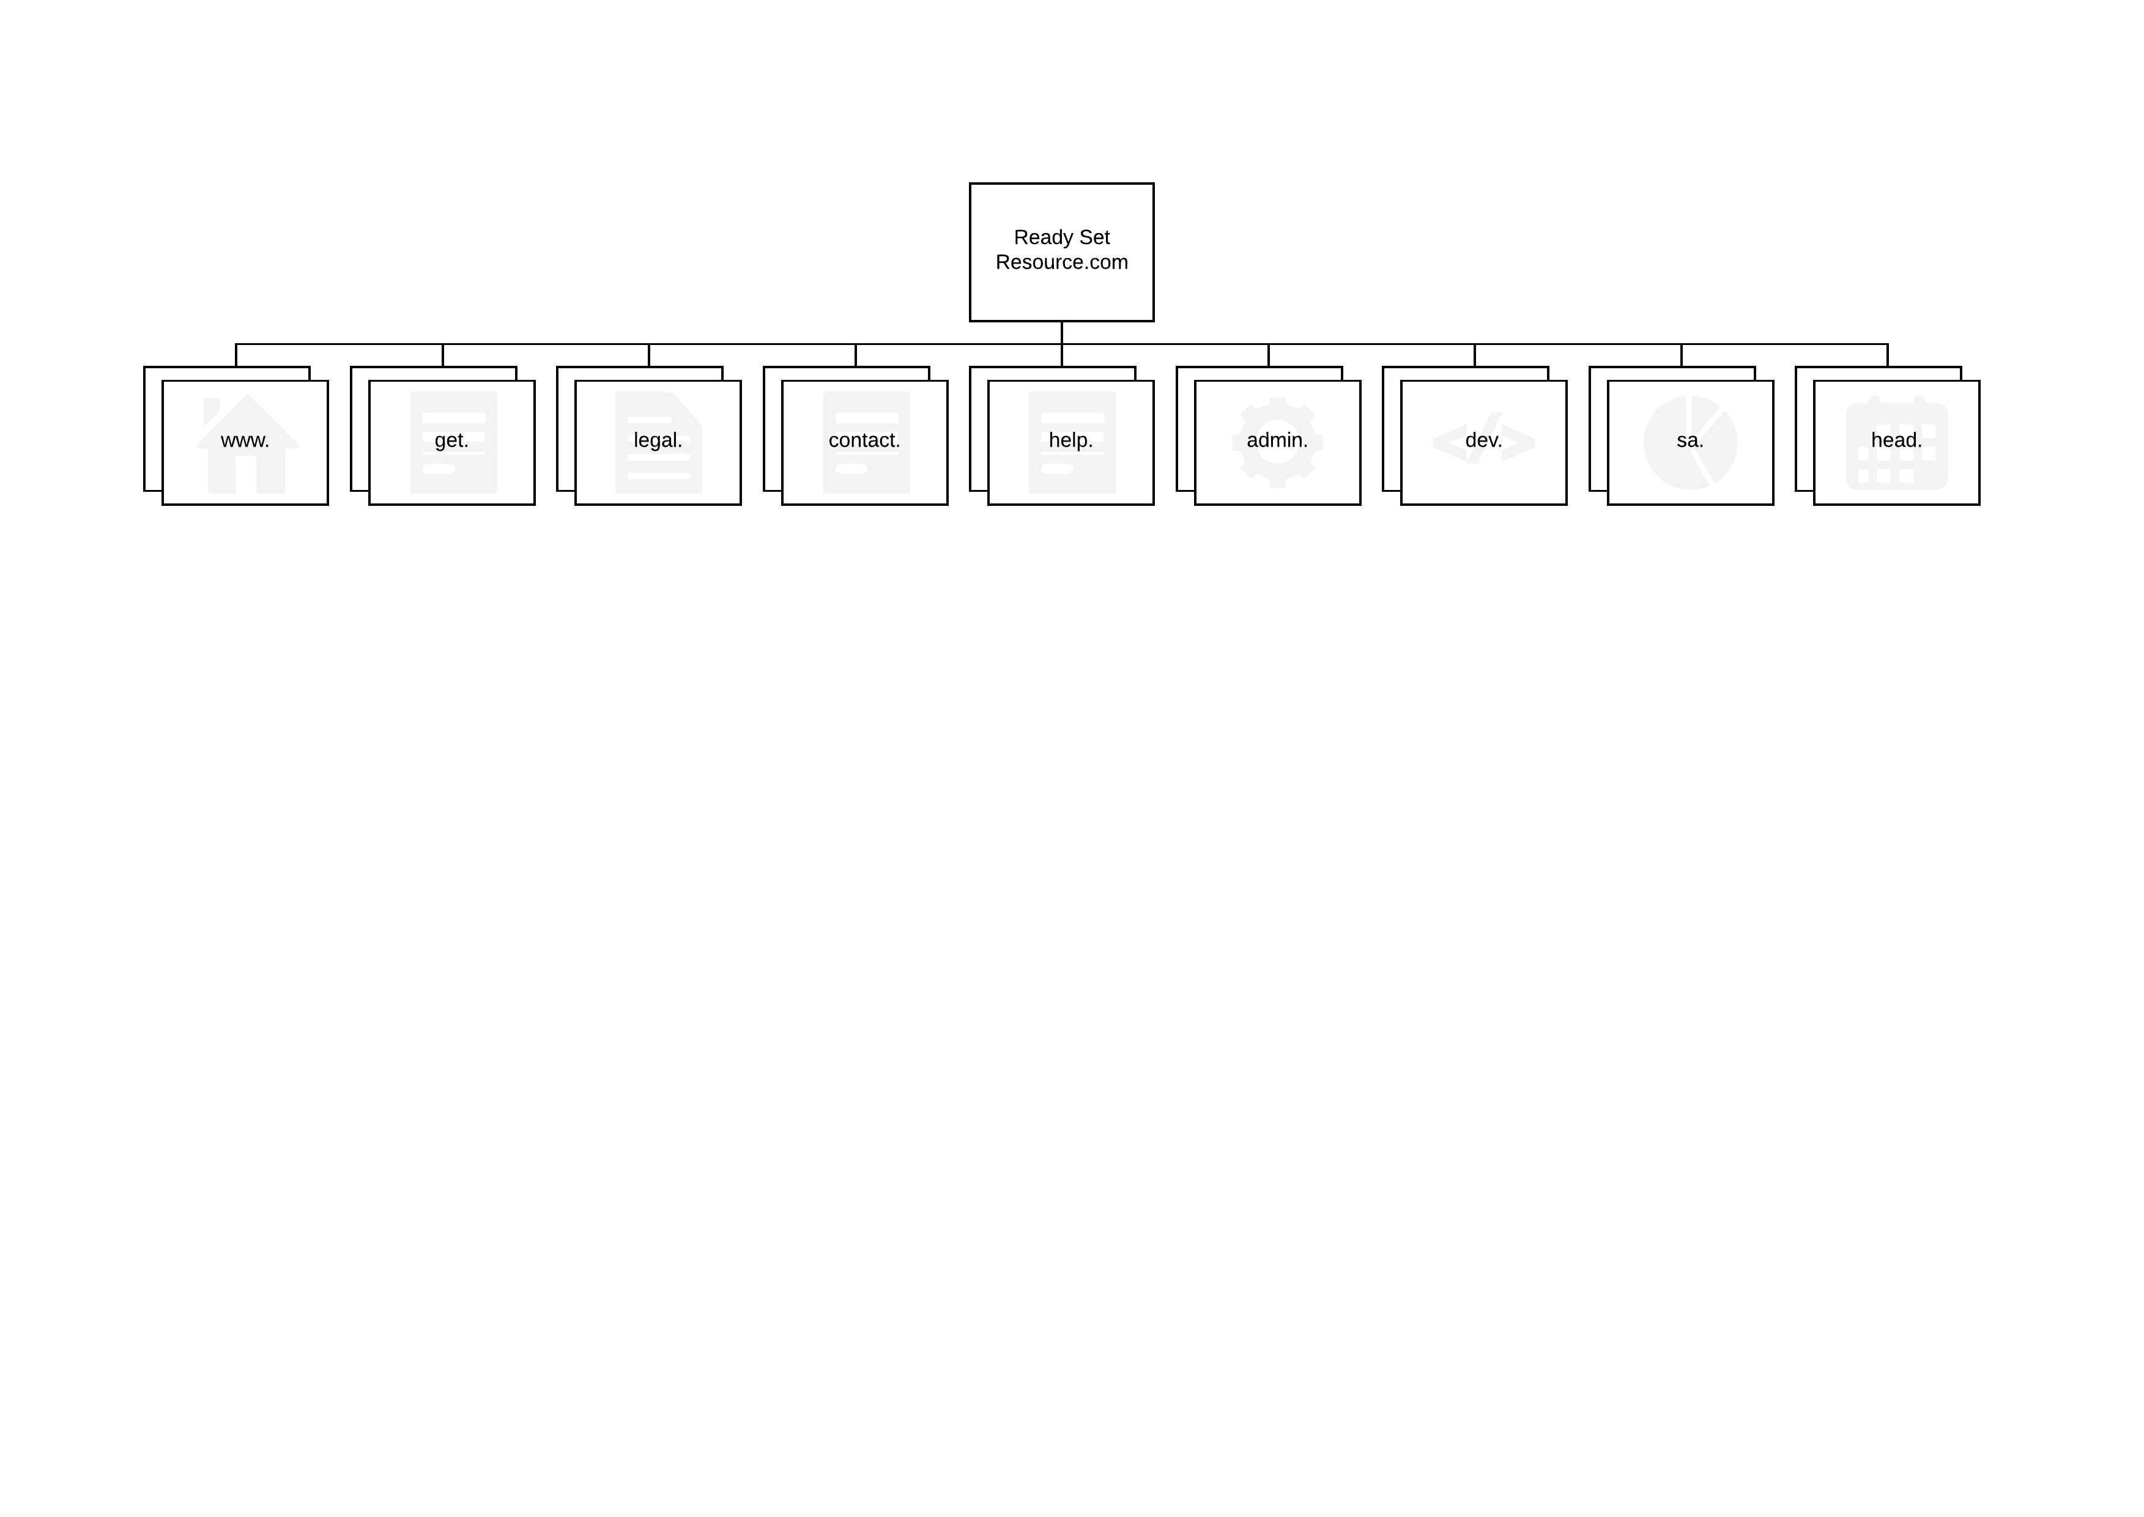high level map of the system being constructed:

www.

This website will contain all the information over our services. When a potential customer searches for this system, they will be directed to this website. On the website they will receive information over how the system works, and links to other websites in the same system to be able to complete their requested action (for example logging on or signing 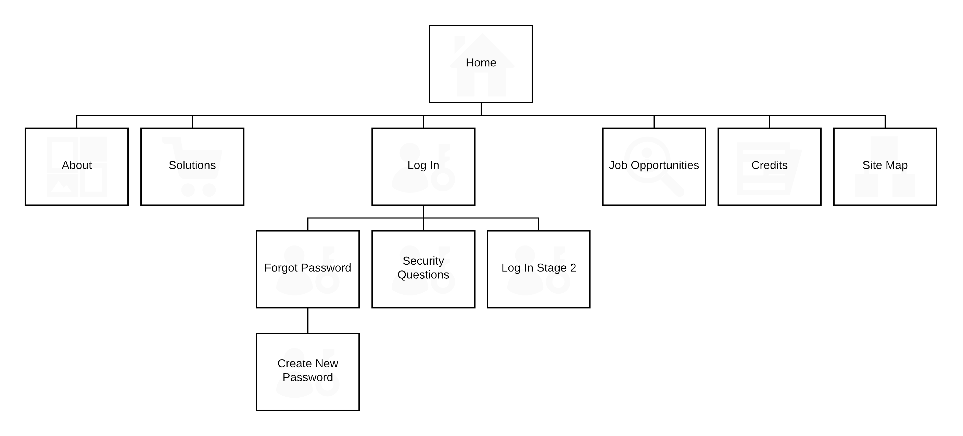up). This will be a hierarchical website.

get.

This website will simply contain the system’s registration process. An easy 3 step process that takes customer information and creates an instance in the system and adds it into the database. This will be a linear website.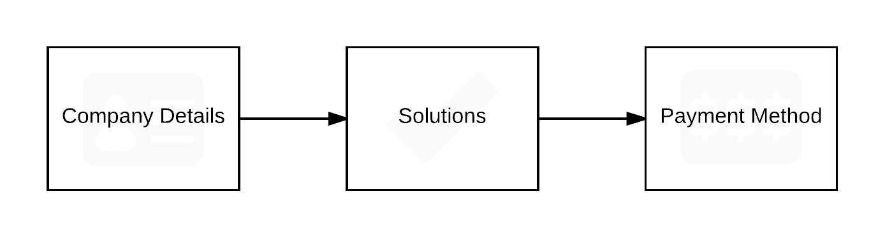

legal.

This website will contain the system’s legal concerns. Another small website that is concerned with providing the system’s visitors and customers our terms and conditions, copyright policy and privacy policy. This will be a hierarchical website.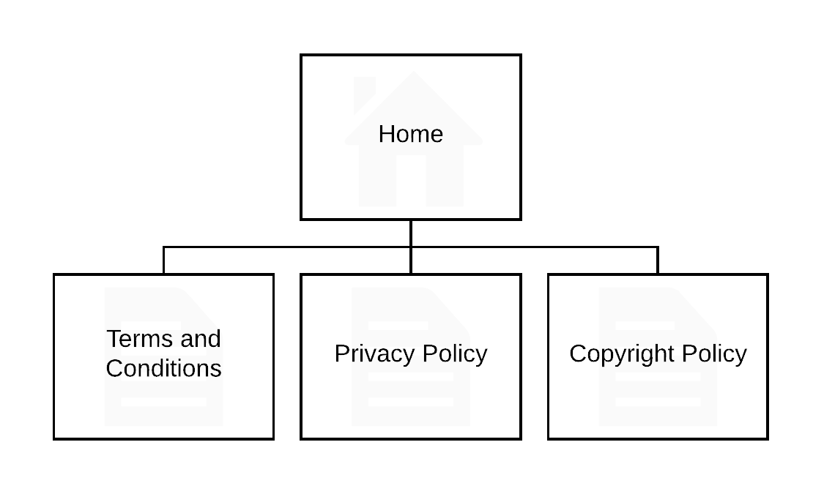

contact.

This website will be concerned with allowing the customer to contact us regarding issues they are having with the system. This website allows the customer to fill out a form and it will be saved to the database allowing an employee to reply. This will be a linear website.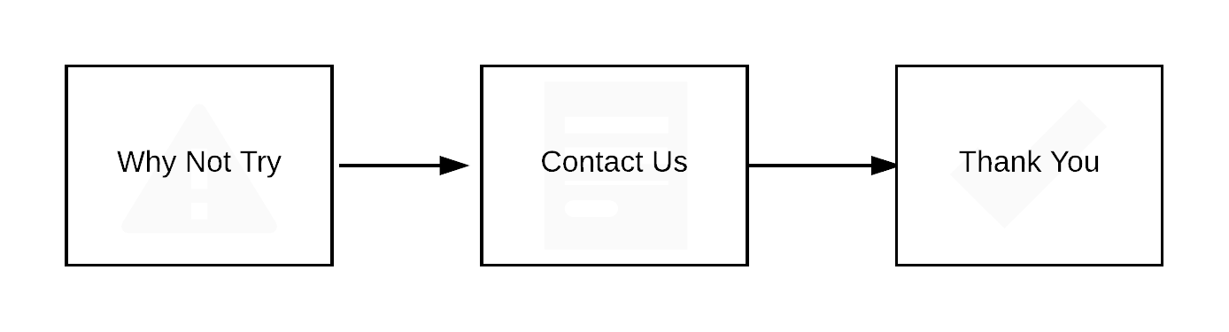

help.

This website will produce a platform for users to be able to ask questions and answer questions. It will create a community of workers that will be able to discuss topics and help 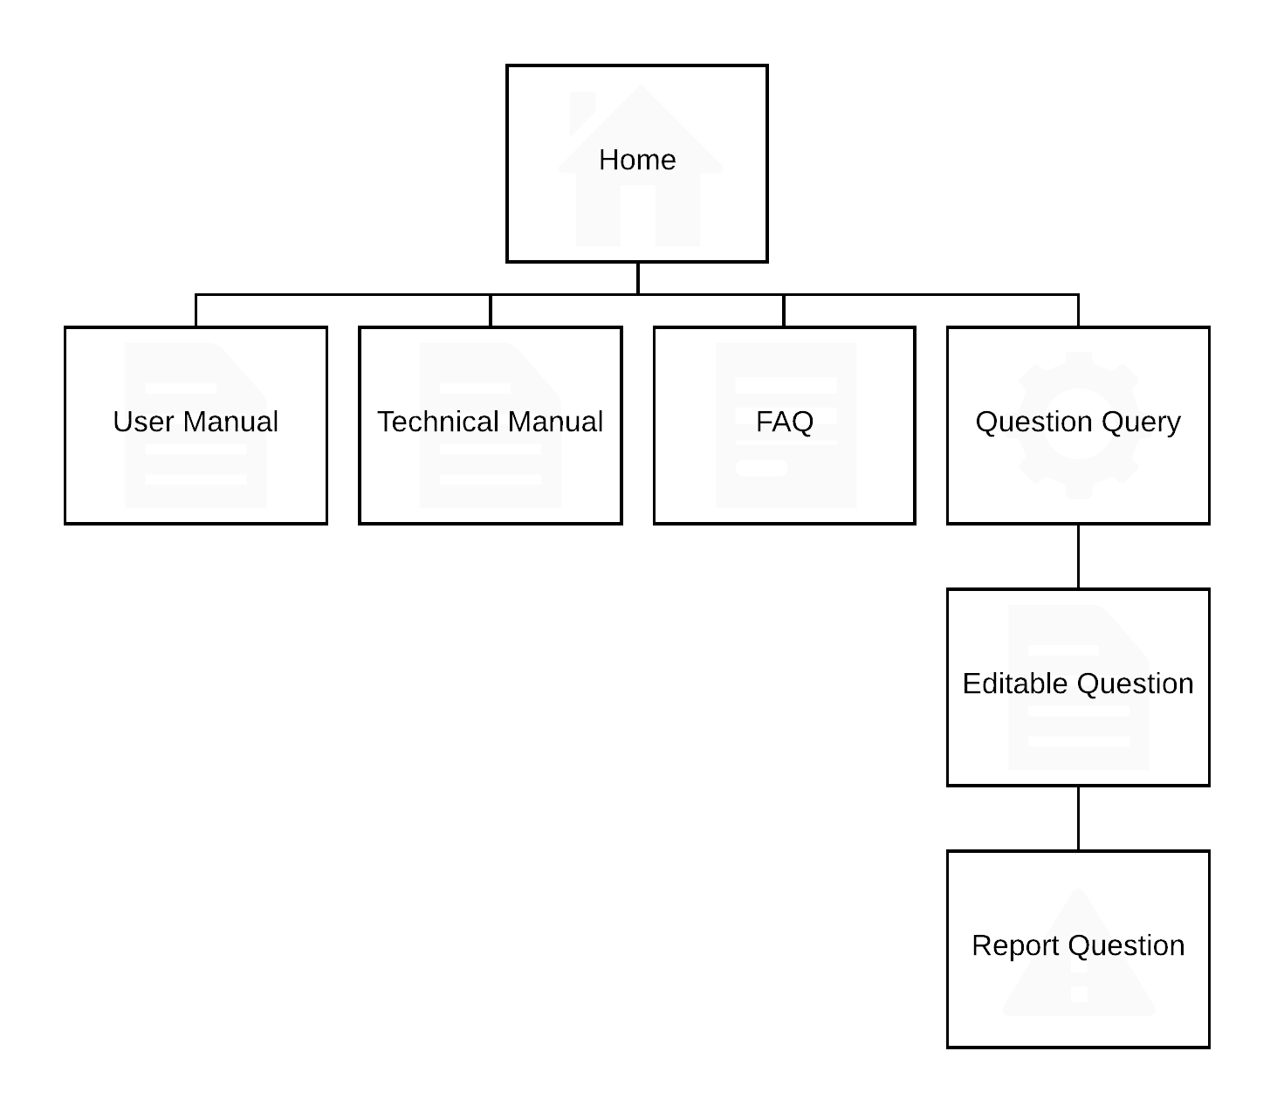each other out. This will be a hierarchical website.

admin.

This website will be for employees of the system. It will form a platform so that ‘experts’ can answer questions that users have asked via the ‘contact.’ website. This will be a hierarchical website.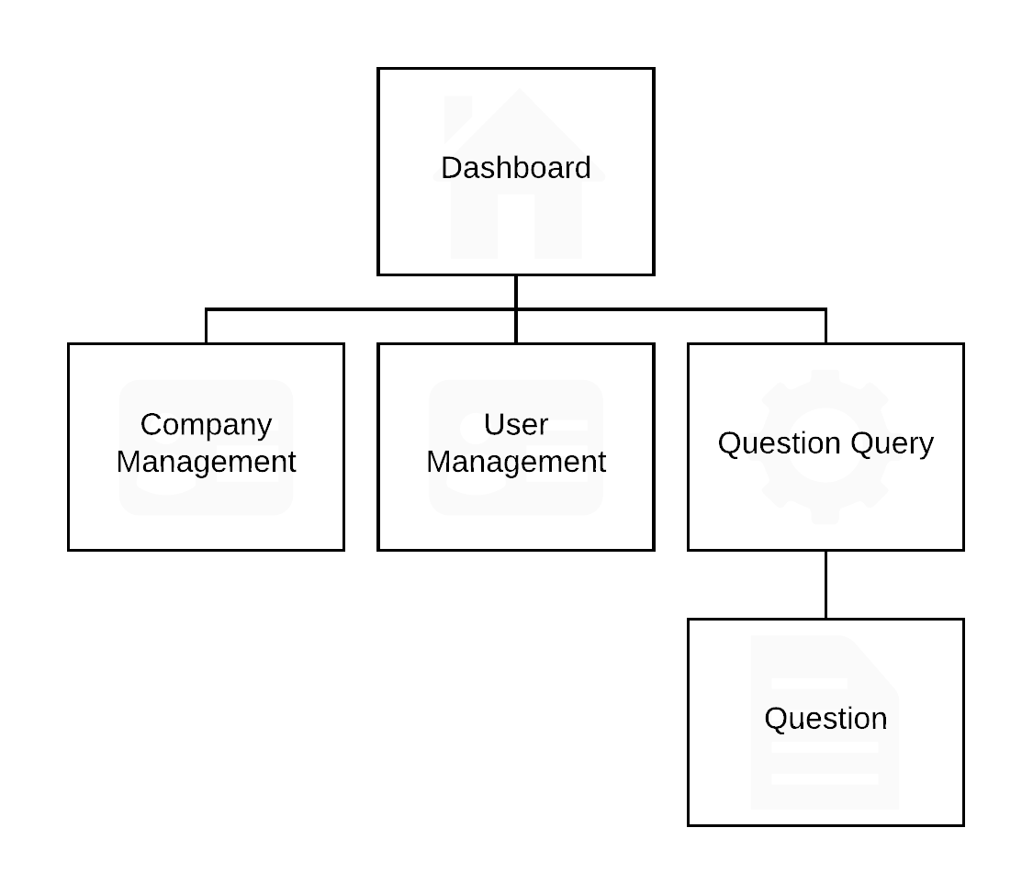

dev.

This website will be for employees of the system. It will form a platform so that ‘developers’ of the system can run reports to see how the system is coping, any errors the system has encountered and the ability to start up and shut down the system. This will be a hierarchical website.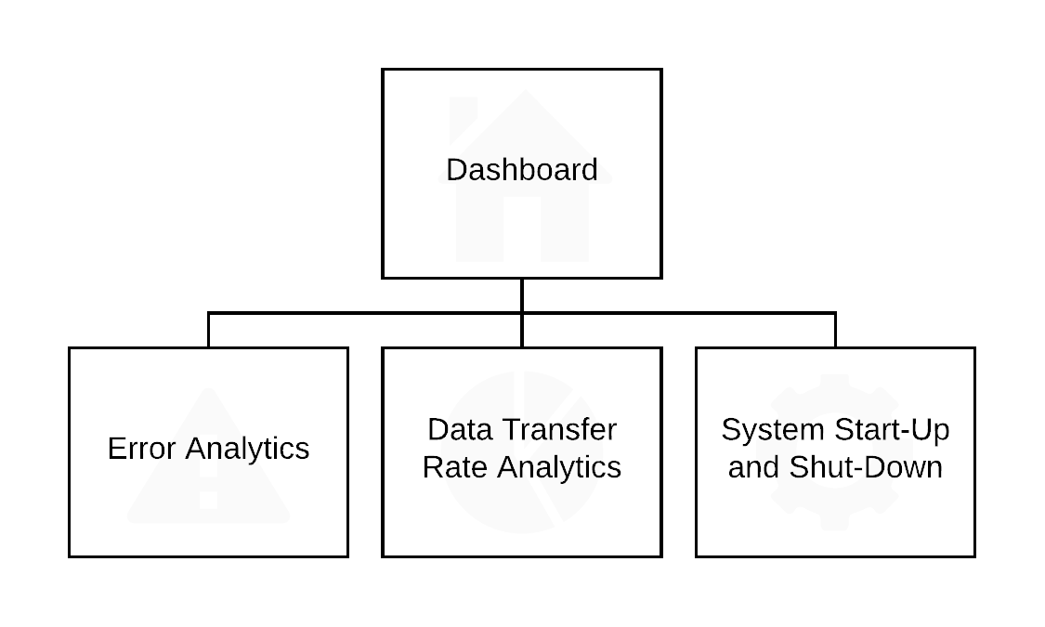

sa.

This website will be for employees of the system. It will form a platform so that ‘systems analysts’ can run reports to analyse trends of usage and management of storage space. This will be a hierarchical website.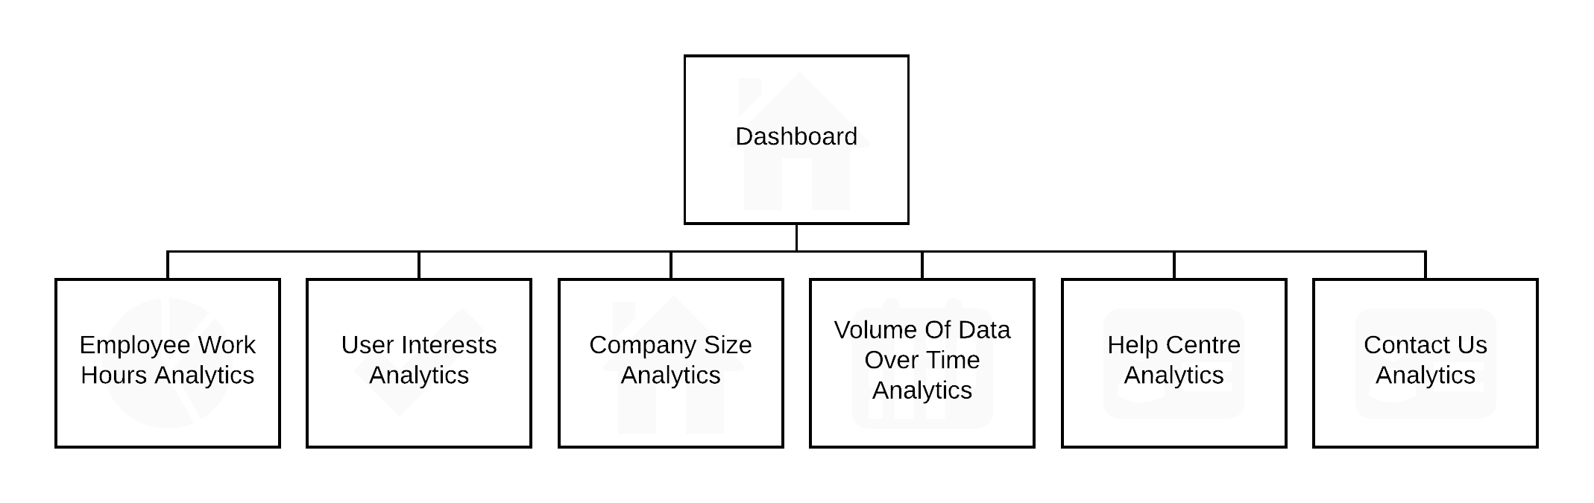

head.

This website will be for employees of the system. It will form a platform so that the ‘COO’ manage their employees and see how the company is doing. This will be a hierarchical 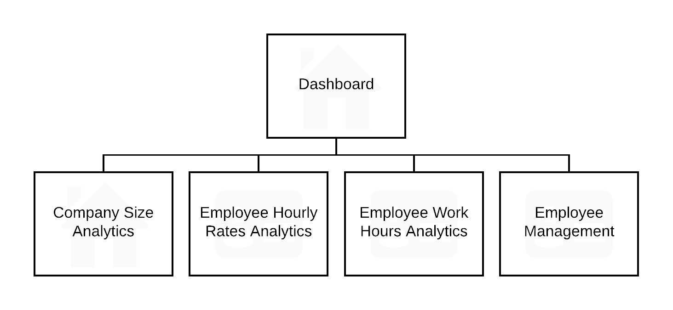website.

im.

This website will be for customers of the system. It is the reason the system was developed. It provides 6 applications: Rota, Updates, Ideas, Employee Store, Messenger and Meetings. This will be a hierarchical website for both customers that are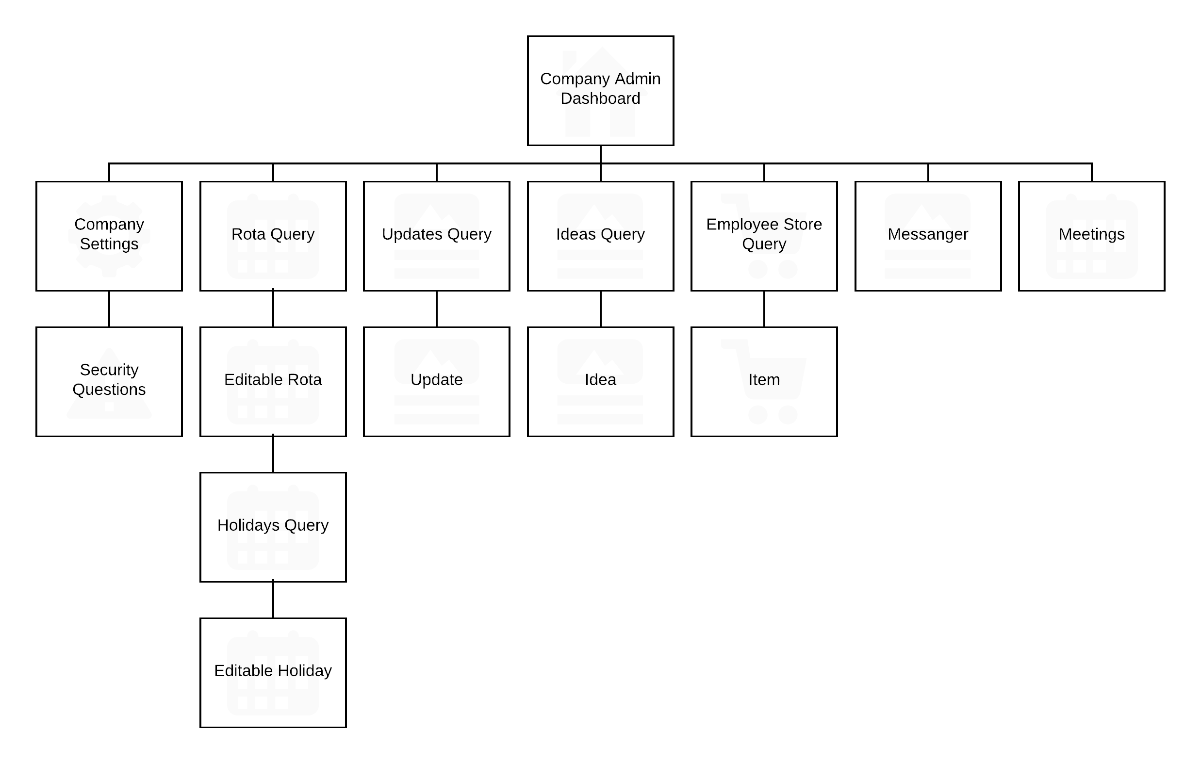 administrators and employees.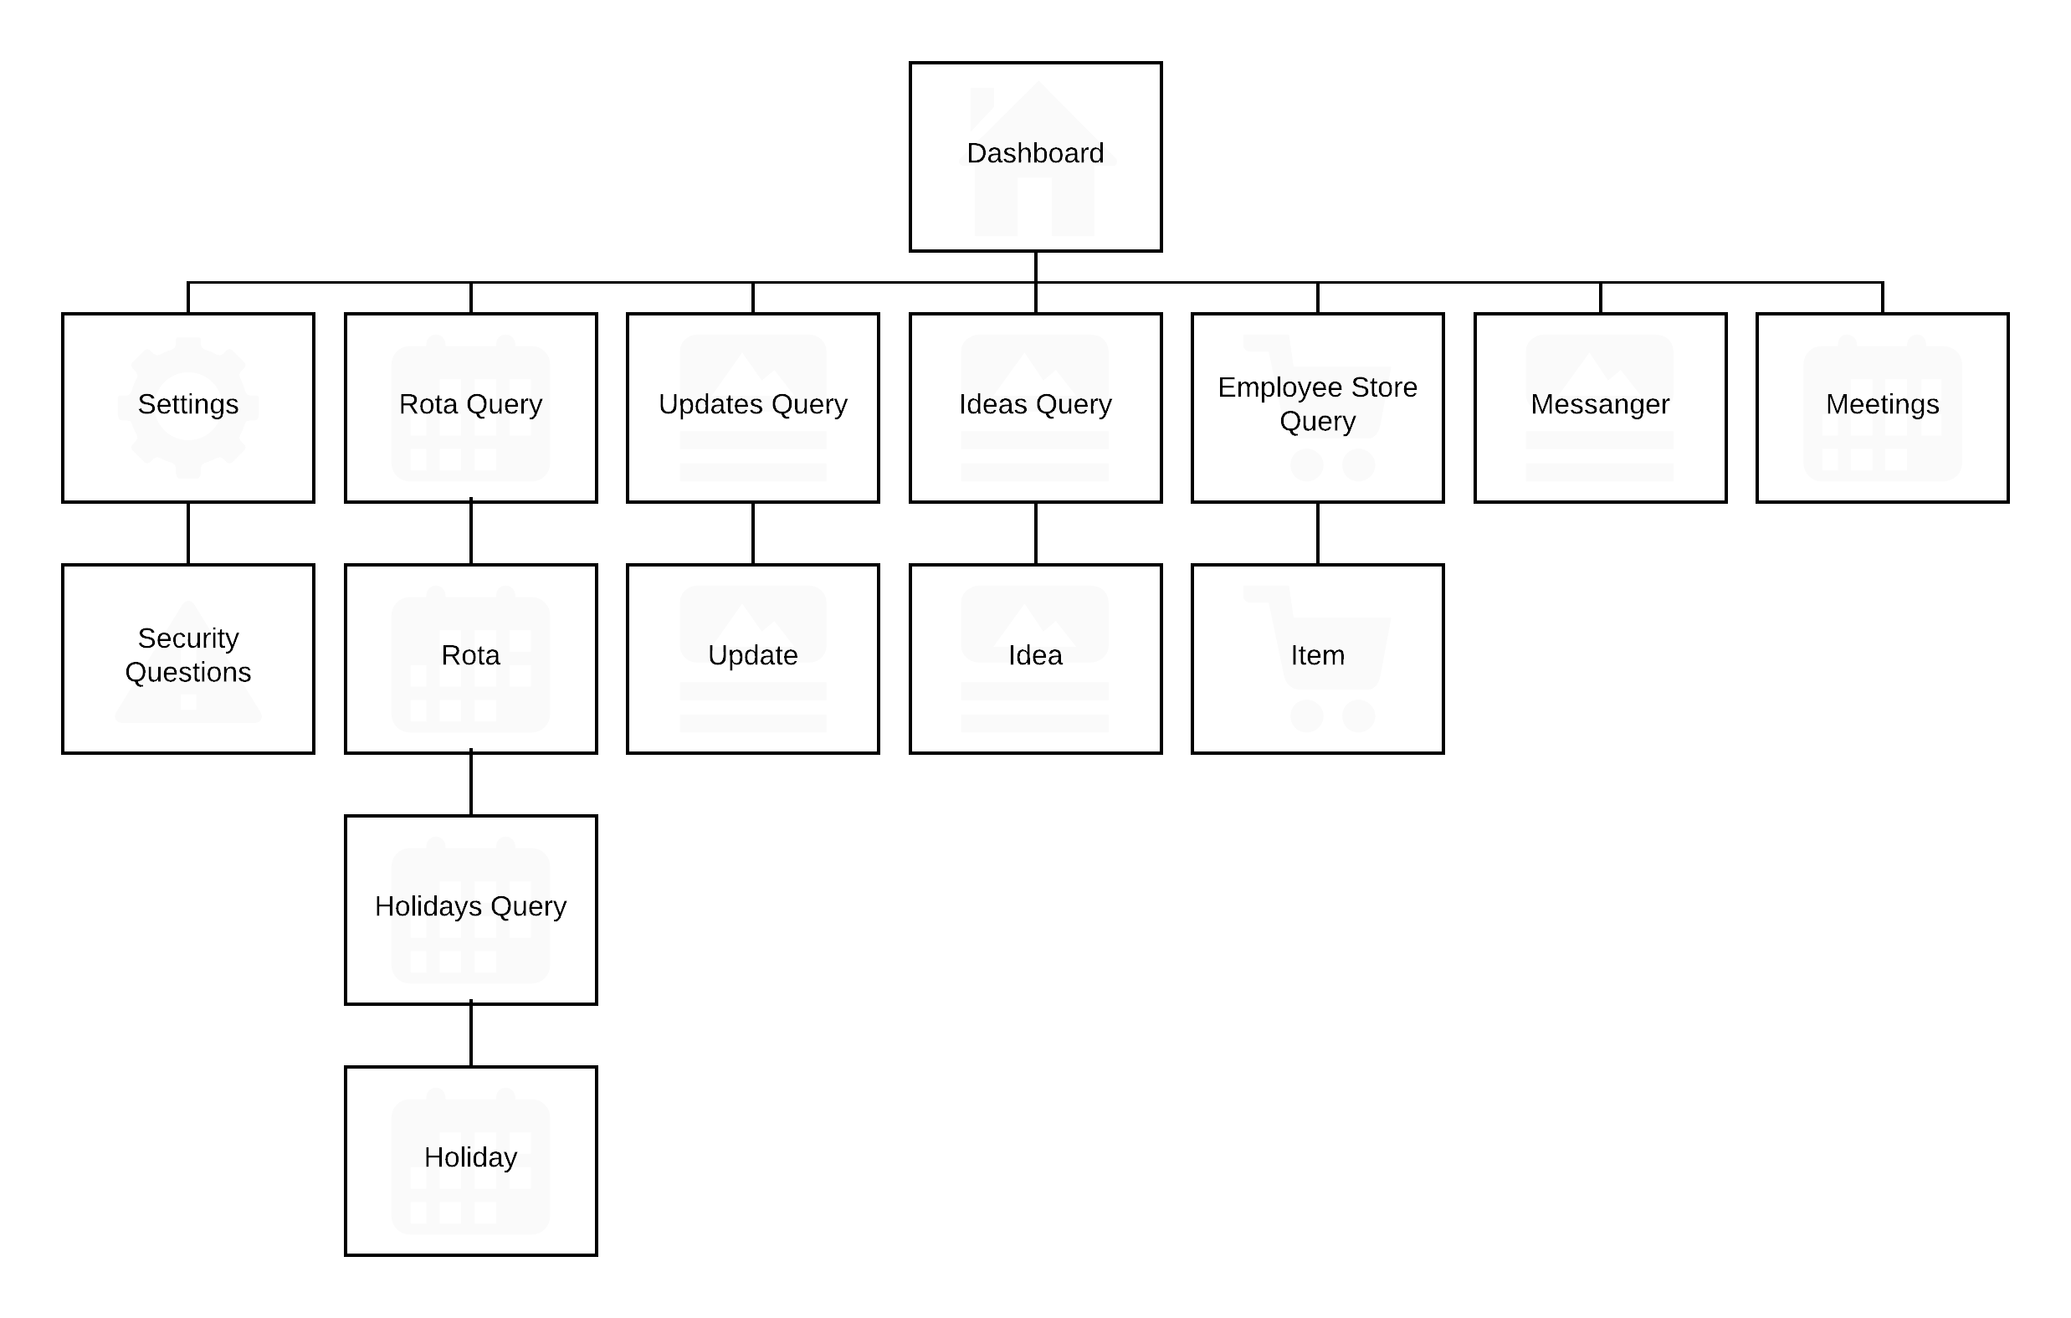

# 4.9 - Bibliography

City of Glasgow College (2017) Integrative Unit [online]. Available from the World Wide Web: <https://my.cityofglasgowcollege.ac.uk/courses/course/view.php?id=1240> [accessed 21 November, 2017]

# 4.10 - Software Requirements Spec. Work Log

| Entry | Description | Person | Date | Mins Spent |
| --- | --- | --- | --- | --- |
| 1 | Formatted the document | Aidan Marshall | 2/11/17 | 17 |
| 2 | Thought about the purpose of the project | Aidan Marshall | 5/11/17 | 19 |
| 3 | Started the critical requirements | Aidan Marshall | 16/11/17 | 42 |
| 4 | Edited critical requirements | Aidan Marshall | 21/11/17 | 12 |
| 5 | Described the functional requirements | Aidan Marshall | 21/11/17 | 4 |
| 6 | Described the non-functional requirements | Aidan Marshall | 22/11/17 | 46 |
| 7 | Thought about the project’s constraints | Aidan Marshall | 22/11/17 | 26 |
| 8 | Thought about the dependencies of the project | Aidan Marshall | 22/11/17 | 7 |
| 9 | Started figuring out the high system logic | Aidan Marshall | 22/11/17 | 206 |
| 379 | | | | |